National Real-Time Payments System – Solutions
This document presents the architectural design and analysis of a National Real-Time Payments System capable of handling large-scale digital transactions across the country. The system is designed to support millions of users and process high transaction volumes with low latency, high availability, and strong security.
The report outlines key subsystems, data flow, potential failure points, mitigation strategies, and architectural trade-offs. It also explores global implementations and suggests additional features such as AI-based fraud detection and cross-border payments.
The proposed architecture ensures scalability, reliability, and compliance with financial regulations, making it suitable as a national financial infrastructure.
Introduction:
With the rapid growth of digital payments, there is a need for a robust, scalable, and secure system that enables real-time financial transactions across the country. A National Real-Time Payments System acts as the backbone of digital financial infrastructure, allowing individuals, businesses, and banks to transfer money instantly.
This assignment focuses on designing a high-level architecture for such a system, considering functional and non-functional requirements such as performance, security, scalability, and reliability.
The system is expected to handle millions of users, support thousands of transactions per second, and maintain near-zero downtime. Additionally, the architecture must be future-ready to support cross-border payments and integration with international financial systems.

Architectural Diagram:
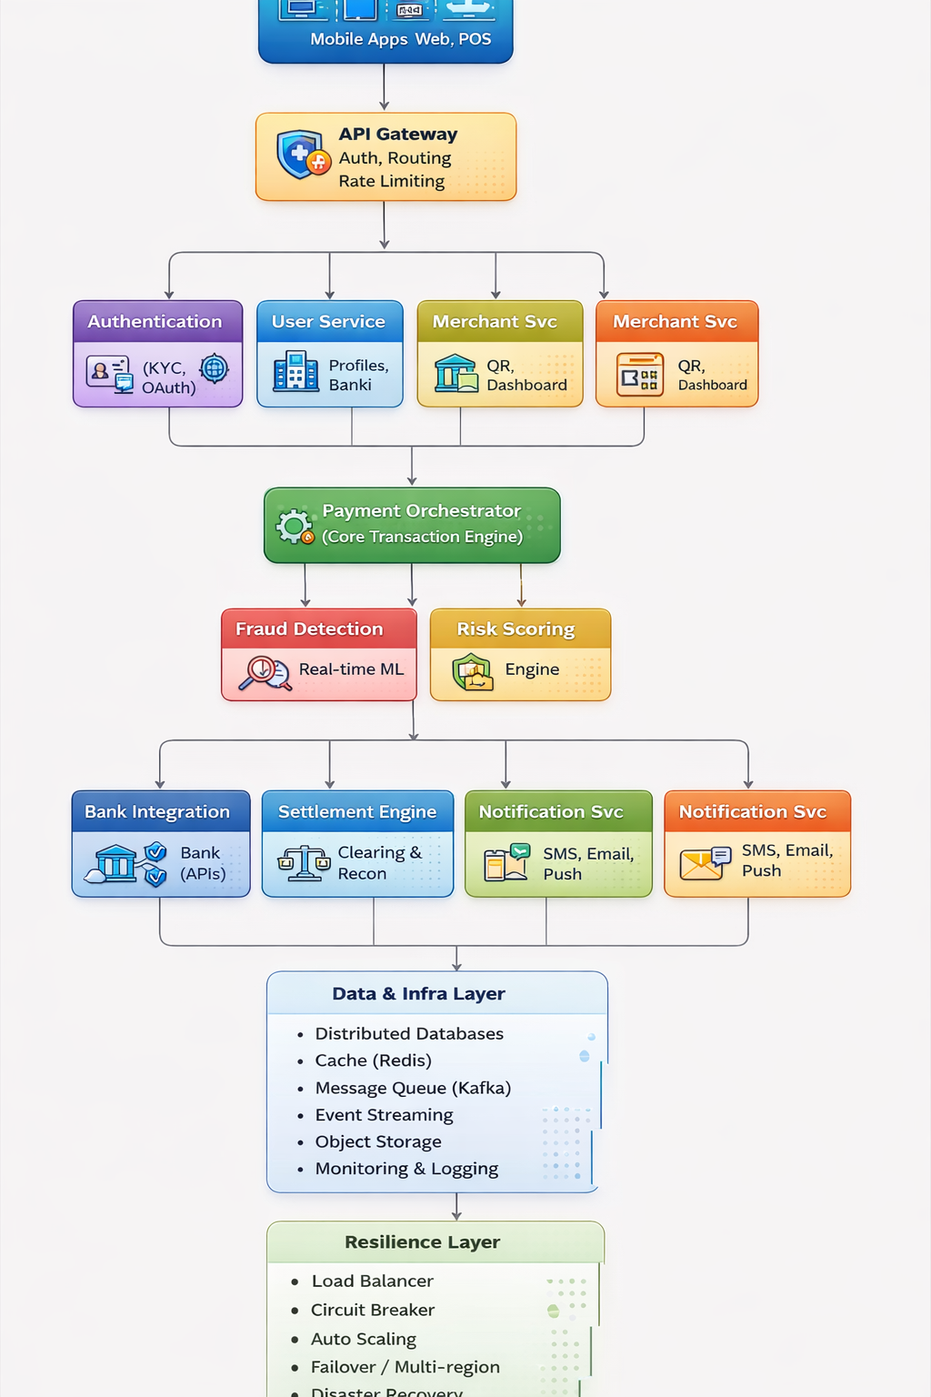
Problem Statement:
The objective is to design a National Real-Time Payments System that:
- Supports 150 million users
- Handles 50,000+ transactions per second
- Provides transaction latency of less than 2 seconds
- Ensures 99.999% availability
- Maintains strong security and compliance standards
The system must also handle peak loads, partial failures, and future expansion to international payments.
Scope:
This document covers:
- System architecture design
- Subsystems and components
- Data flow and communication
- Failure handling strategies
- Scalability and performance considerations
- Trade-offs and design decisions
Considering the above requirements:

1. Systems and Subsystems Required
To build a large-scale real-time payments platform, the architecture must be modular, scalable, and resilient. The key systems are:
1.1 User Management System
- User onboarding (KYC verification)
- Profile management
- Bank account linking
- Authentication (OTP, biometrics)
1.2 Payment Processing System
- Transaction initiation
- Validation (balance, fraud checks)
- Routing to appropriate bank
- Real-time processing engine
1.3 Bank Integration Layer
- APIs for communication with banks
- Adapter layer for different bank protocols
- Retry and fallback mechanisms

1.4 Settlement & Reconciliation System
- Inter-bank settlement
- Scheduled settlements
- Ledger management
- Reconciliation engine
1.5 Fraud Detection System
- Real-time fraud scoring
- Machine learning models
- Rule-based engine
1.6 Notification System
- SMS, Email, Push notifications
- Real-time transaction alerts
1.7 Merchant Management System
- Merchant onboarding
- QR code generation
- Reporting dashboards
1.8 Admin & Regulatory System
- Monitoring dashboards
- Audit logs
- Compliance reporting
1.9 API Gateway
- Entry point for all external requests
- Rate limiting
- Authentication & routing
1.10 Data Storage Systems
- Transaction database (high consistency)
- User database
- Logs and analytics storage
1.11 Monitoring & Observability
- Real-time monitoring
- Logging and tracing
- Alerting systems
2. Information Exchange Between Systems
2.1 Types of Data Exchanged
- User data (KYC, profile)
- Transaction data (amount, status)
- Bank responses (success/failure)
- Fraud signals
- Audit logs
2.2 Communication Characteristics
Parameter | Requirement
Frequency | Very high (50,000+ TPS)
Speed | Sub-second response
Volume | Massive (millions of transactions daily)
Consistency | Strong consistency for financial data
2.3 Communication Patterns
- Synchronous APIs → Payment processing
- Asynchronous Messaging (Kafka/RabbitMQ) → Notifications, logs
- Event-driven architecture → Scalability
3. Major Potential Failure Points:
3.1 Technical Failures
- Server crashes
- Database outages
- Network latency
3.2 Integration Failures
- Bank APIs unavailable
- Timeout errors
- Version incompatibility
3.3 External Dependency Failures
- Payment gateways
- Third-party KYC services
- SMS/notification providers
3.4 Data Failures
- Data inconsistency
- Partial transaction completion
- Duplicate transactions
4. Mitigation Strategies
4.1 Redundancy
- Multi-region deployment
- Active-active data centres
4.2 Circuit Breakers
- Prevent cascading failures
- Isolate failing services
4.3 Retry Mechanisms
- Exponential backoff
- Idempotency keys to avoid duplicates
4.4 Load Balancing
- Distribute traffic across servers
4.5 Caching
- Reduce database load
4.6 Data Replication
- Real-time backups
- Disaster recovery
4.7 Graceful Degradation
- Limited functionality during failures
5. Contingency Plans
5.1 Manual Reconciliation
- Resolve failed or pending transactions
- Audit mismatches
5.2 Deferred Settlements
- Queue transactions during outages
- Process later
5.3 User Communication
- Notify delays or failures
- Provide transaction status updates
5.4 Failover Systems
- Switch to backup systems automatically
5.5 Dispute Resolution Mechanism
- Chargeback handling
- Refund workflows
6. System Behavior Under Different Loads
6.1 Normal Daily Load
- Standard auto-scaling
- Real-time processing
- Full fraud checks
6.2 Peak Events (10x Load)
- Aggressive auto-scaling
- Prioritize critical transactions
- Rate limiting for non-critical services
- Use queue-based processing
- Defer non-essential operations (reports, analytics)
7. Architectural Trade-offs
7.1 Consistency vs Availability
- Prefer strong consistency for transactions
- Use eventual consistency for logs and analytics
7.2 Cost vs Reliability
- High reliability requires:
  - Multi-region deployments
  - Redundancy
- Trade-off: Increased infrastructure cost
7.3 Real-time vs Eventual Processing
- Real-time → Payments
- Eventual → Notifications, reports
7.4 Security vs User Experience
- Strong authentication improves security
- But increases friction
- Balance with:
  - Biometrics
  - Risk-based authentication
8. Global Implementations & Recommended Features
8.1 Global Systems
- Unified Payments Interface (UPI – India)
- Faster Payments Service (UK)
- SEPA Instant Credit Transfer (Europe)
- FedNow (USA)

8.2 Recommended Additional Features
1. AI-Based Fraud Detection
- Real-time risk scoring
- Behavioral analytics
Impact: Reduces fraud losses
ROI: High
2. Offline Payments (Low Connectivity Mode)
- Token-based offline transactions
Impact: Financial inclusion
ROI: Medium to High
3. Cross-Border Payments
- Currency conversion
- Real-time settlement
Impact: Global scalability
ROI: Very High
4. Credit on UPI (Buy Now Pay Later)
- Small credit lines for users
Impact: Increased transaction volume
ROI: High
5. Smart Merchant Analytics
- Sales insights
- Customer trends
Impact: Merchant retention
ROI: Medium
6. Voice-Based Payments
- Useful for accessibility
Impact: Wider adoption
ROI: Medium
7. Open API Ecosystem
- Third-party integrations
- Fintech innovation
Impact: Platform growth
ROI: Very High
Conclusion:
The National Real-Time Payments System must be:
- Highly scalable (50,000+ TPS)
- Fault-tolerant (99.999% availability)
- Secure and compliant
- Real-time with minimal latency
By adopting:
- Microservices architecture
- Event-driven design
- Strong monitoring and resilience patterns
The system can serve as a national financial backbone and expand globally for cross-border payments.

